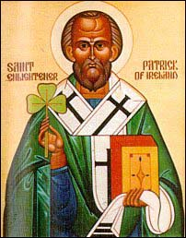
ST. STEPHEN THE MARTYR
A. C. W.

Are Hosting an Irish Stew Dinner in
Celebration of St. Patrick
A Vegan Alternative will also be offered

SATURDAY – MARCH 14th, 2020
at

11723 - 93 STREET, EDMONTON
(PRAYERWORKS HALL)

TIME: 5:00 P.M. - 6.30 P.M.

ADMISSION - $10.00
CHILDREN UNDER 6 FREE.

PLEASE JOIN US, ALL AGES ARE WELCOME

