Creating a Sacred Space at Home
The Rev. Sheila Hagan-Bloxham
Honorary Assistant, St. George’s, Edmonton
Now that circumstances have made it impossible for us to worship within the walls of a building that we have erroneously called ‘church’ for so long, many of us are beginning to recognize that church is the body dispersed across the city, province or country. We are the church. You and I, in our mortal human bodies, live the church.
Through the gift of technology, we have come to recognise that we can still, even need to, come together in fellowship. During the COVID-10 crisis, in this time of social distancing, technology brings us together, and in one another’s faces we see we are not alone. We still see the face of Christ reflected in the faces of our friends whom we have grown accustomed to gathering with on Sunday morning. We have come to realise is that this a possibility in any place where we can open our tablet or computer to pray together - at our desk or on the kitchen counter. We can still, bring our concerns to the group gathered, give thanks for our blessing and imagine we are at coffee hour.
So, where in our own homes can we find sacred space? The answer is: anywhere we choose. The main requirement is that it be a place set aside, just as a church building is, to intentionally meet God. Most Christians begin with a Bible. Some also add a cross. Other possible items to include in your sacred space are prayer beads (there are Anglican prayer beads available), a finger labyrinth and so on. A sacred space can incorporate personal objects, such as photographs and reminders of times when we have encountered God in the past. Those with young children may ask for their assistance and invite them to include a favourite toy or book.
When approaching the sacred space with the intent of opening to God’s Presence, which always surrounds us, I like to say a prayer, such as:
I know that I am always in your sight Holy God,
at this time I am turning myself with full awareness that you see and know me,
I give thanks for this promise. In Jesus’ name Amen.
I also light a candle to remind me that the Holy Spirit is present. At the end of the prayer or worship time I extinguish the candle, reminding myself that the Spirit continues to remain with me. Remember: it is the intention, not the words, that is important. God already knows your heart.
If you choose, you might use this space in your home when the church gathers on Sunday mornings or whenever the time is set for gathering. In this way, the space will become even more sacred as you worship with fellow Christians from your own home.
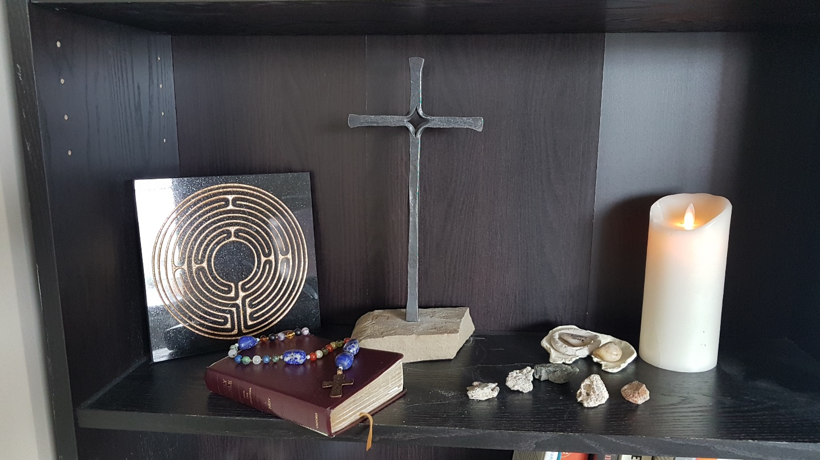

Caption: a typical home sacred space: a finger labyrinth, a cross, a Holy Bible, prayer beads, rocks collected from thin places (holy sites), remembrances of an earlier retreat, a candle

