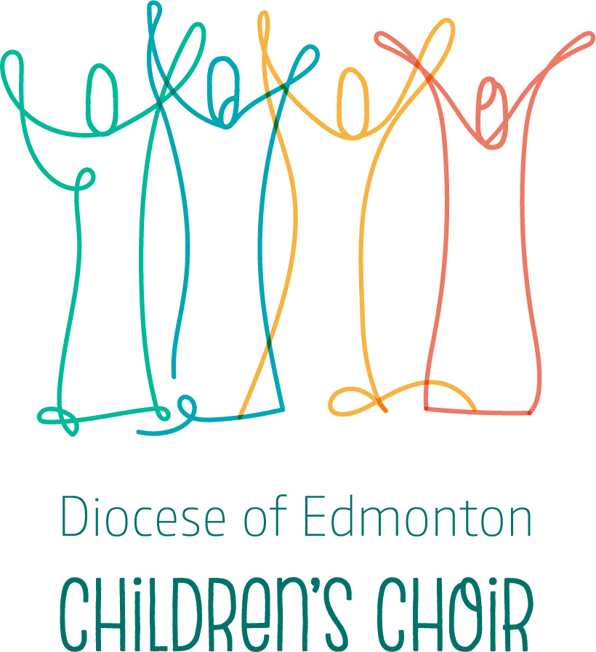
December 8, 2021

Dear friends,
We are so pleased to announce the advent of a new diocesan choir for children and youth: the “Diocese of Edmonton Children’s Choir.” Conducted by Laura Hawley, this choir will rehearse on Wednesday evenings, 5-6, at Christ Church (12116 - 102 Ave, Edmonton), beginning January 19. If you are 7 and up, we would love to have you in this choir, where we will be learning music connected to the church’s worship, and will be offering this music at church services throughout the diocese and special liturgical events, i.e. Lessons and Carols, throughout the year. We will begin on January 19 and, for this season, we will be rehearsing into mid-May (2022).
As we continue to live in the midst of COVID, the following protocols will be followed as we begin:
1. Singers must wear a mask whenever they are inside.
2. Singers should maintain a distance of 6 feet (2 metres) while inside.
3. Singers will have a small number of seating plans or standing arrangements used from week to week to limit close contacts.
4. Singers must provide their own water bottle, and no sharing between singing.
5. Singers who are 12 and up must be fully vaccinated.
6. Close physical contact (i.e. hugging) during rehearsals is discouraged. Elbow bumps or air fives are great!
7. Singers who are not feeling well or who have had close-contact with anyone who is feeling unwell or has been diagnosed with COVID-19 must not attend rehearsal in person.

This choir is for everyone – no audition is required, no payment is requested. Our first rehearsal on January 19 will be open to ‘come and try’ what this choir is all about! For our best planning, we would love to know that you are coming to this first open rehearsal, so thank-you for registering by January 12, 2022.
Click here to register.

In Christ,
Dr. Joy Berg, Christ Church music director

Bio:
Laura Hawley

