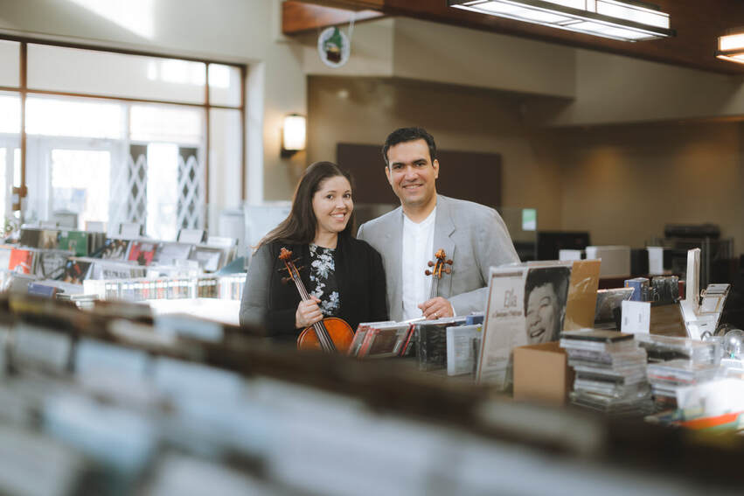

Let’s Spend a Night Listening to a Duet of Classical Music! With the Amorim-Rufino Duo!
​Brazilian-Canadian Violinist Vladimir Rufino and Brazilian-Canadian violist Fabiola Amorim have been performing together as a duo as well as with orchestras and chamber ensembles in Brazil, United States and Canada since 2005.

Cost: Free
That’s right, free. Why? Everything costs too much right now. Let’s take a break. Enter into a quiet room, enjoying the peace of good music in the west side.

The Program-
P. Wranitzky - Sonata I for Violin and Viola
F. A. Hoffmeister - Duo for Violin and Viola Op. 19 No. 4
H. Villa-Lobos - Duo for Violin and Viola
F. Horvat - Two Hearts in Concert

Sponsored by-
St. Peter the Apostle’s Anglican Congregation

Location-
St. Matthias Anglican Church
6210 188 St NW, Edmonton, AB T5T 5T4

Time, Date-
7pm, Thursday August 25th

Please, No donations. Just enjoy yourself.
More info: https://www.amorimrufino.com/about-us.html

