Has this been a tiring summer? Are you "brain tired"? Do you need a break? St. Peter the Apostle Anglican Congregation (meeting at St. Matthias) would like to invite you to enjoy the peace and rest brought by an afternoon of listening to Dvorak. It is a free (we really mean free) concert. We'll be having a Said Holy Eucharist right before without a sermon and then jump into the music of this trio. Be our guest at 2-ish (we always start late) in the building of St. Matthias. Care for young children will be provided for the music.

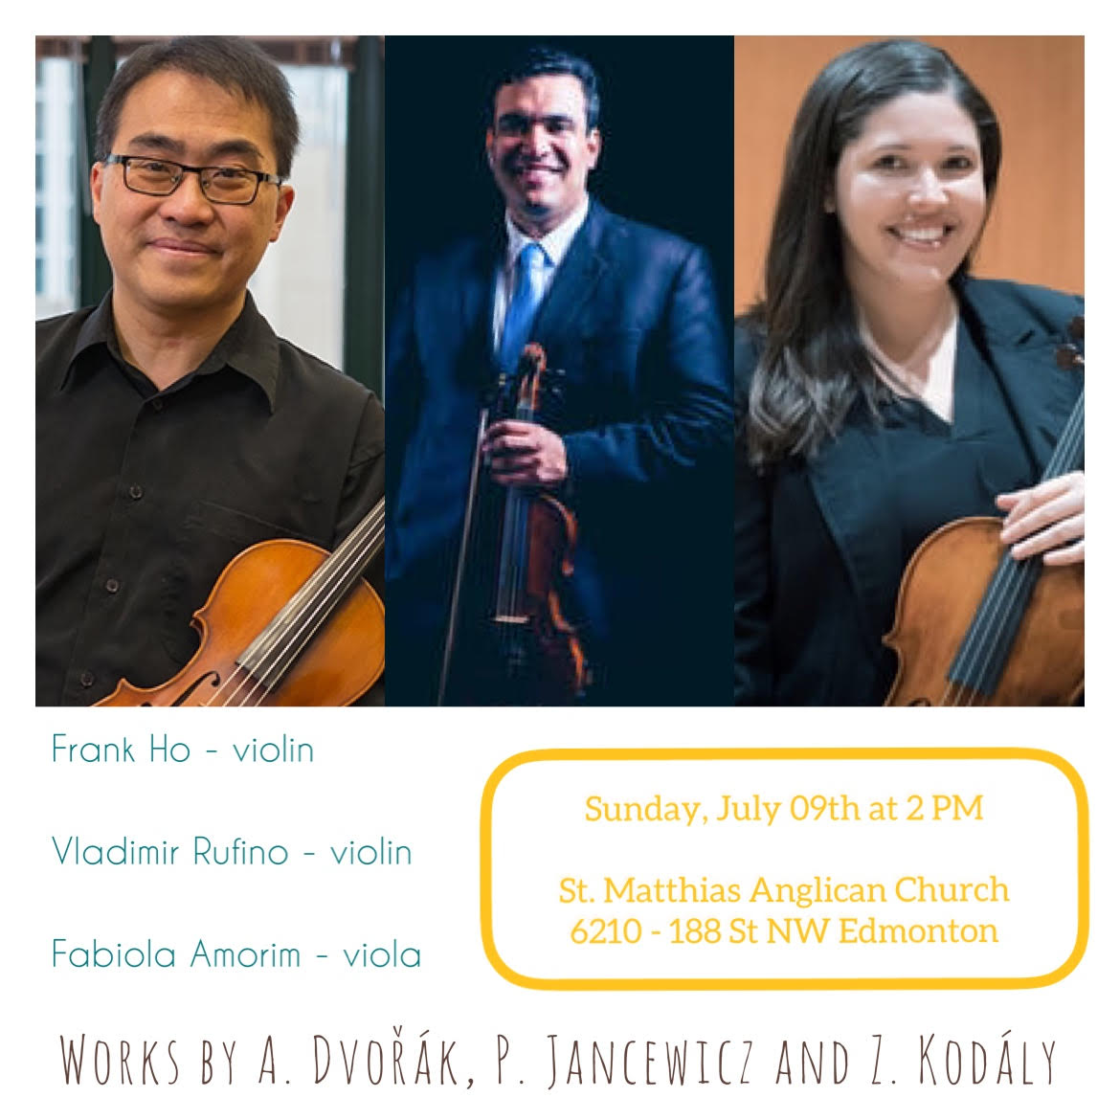
Frank Ho:
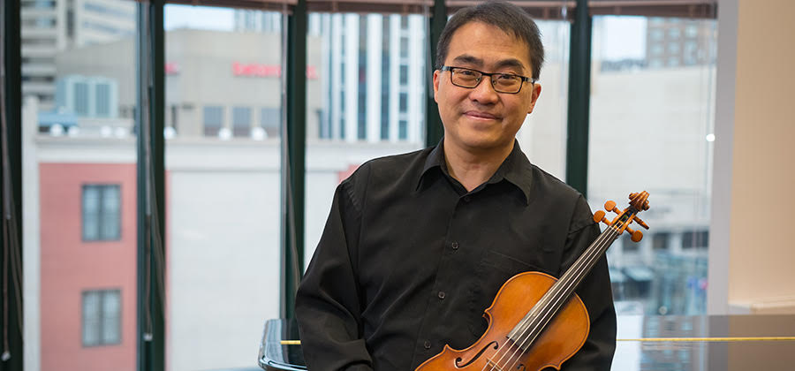
Violinist Frank Ho enjoys a multi-faceted career as a soloist, chamber musician and pedagogue. His early training was at the Alberta College (now MacEwan University) Conservatory of Music. Further studies with Sidney Harth and Erick Friedman (Yale School of Music) and Yfrah Neaman (Guildhall School of Music and Drama in London, England) led to performance opportunities on three continents. Highlights include concerts at prestigious venues such the Royal Festival Hall and the Purcell Room in London; Weill Recital Hall, Alice Tully Hall, and Merkin Hall in New York City; and numerous campuses and concert series in western Canada. Many of his concerts have been featured on the CBC. He is currently a faculty member at the MacEwan University Conservatory of Music, where he also serves as their External Relations Consultant, and sessional violin instructor at King’s University College. Many of his students are previous prizewinners of local, provincial, and national competitions. Most recently, two of his students were chosen to perform at Carnegie Hall. Frank is also an active adjudicator and a member of the College of Examiners for the Royal Conservatory of Music. He is currently the concertmaster of the Concordia Symphony Orchestra. Frank makes his home in Edmonton with his wife, Marry, and their three children: Mackenzie, Jordanne and Dylan.
Vladimir Rufino:
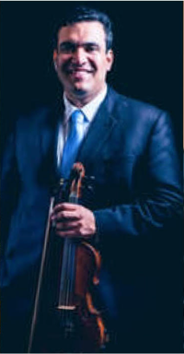
Brazilian-Canadian violinist Vladimir Rufino, has brought his love of music to stages in South America and Europe as well as Canada and the United States. He offers high quality instruction exemplified by his experience with teachers Yerko Pinto Tabilo and Charles Stegeman, and his participation in music festivals and symposia in Brazil, Canada, and the United States including the Starling-Delay Symposium on Violin Studies at The Juilliard School. Vladimir also shares his experience when he adjudicates for festivals and competitions across Alberta. On many occasions, Vladimir has performed with orchestras in Brazil, the United States, and Canada, serving as concertmaster or assistant concertmaster. His chamber music experience includes numerous international performances as part of the Quartet Quarta Dimensão, the Camerata Brasílica, the Villa-Lobos String Quartet, and the Vaughan String Quartet. Besides performing the standard classical repertoire, Vladimir has performed and recorded a number of works by Brazilian composers. Vladimir currently performs regularly with the Edmonton Symphony Orchestra, the Okanagan Symphony orchestra and as first violin of the Vaughan String Quartet, which released its debut CD in 2018.
Fabiola Amorim:
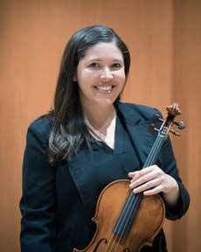
Dr. Amorim maintains an active schedule as a concert violinist and educator. She holds a position of viola instructor at the MacEwan University Conservatory of Music and adjudicates for festivals and competitions in Alberta. Since the publication of her 2018 doctoral thesis Echoes of the Brazilian Nationalism Movement in Four Works for Viola and Piano (1950-82), Amorim’s work has served as a reference for other researchers on Brazilian music for viola. She studied with Mr. Yerko Tabilo, Mr. Charles Stegeman, and Mr. Robert Becker. She is the recipient of numerous scholarships and awards, and participated in a number of music festivals and symposia in Brazil and United States including the Starling-Delay Symposium at The Juilliard School. Amorim has performed as principal viola and soloist with orchestras in Brazil, the United States, and Canada. As a chamber musician she was a member of the Camerata Brasílica (Brazil) and the Villa-Lobos String Quartet (USA). She is also a founding member of the Vaughan String Quartet, which has performed in Canada, USA, France and Italy, and made its debut recording in 2018.

