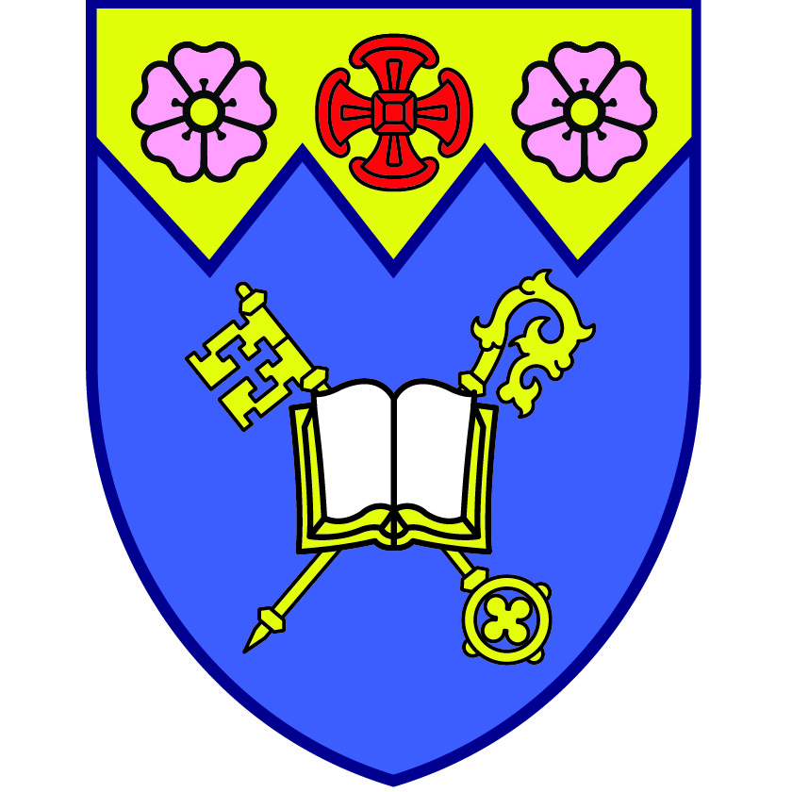
Diocese of Edmonton Family Retreat Weekend
July 7 to 9 at Camp Van Es

ACTIVITIES

Friday

2pm to 5pm – arrival and free time to play, walk or rest

5:30pm – dinner (burgers and salad or tacos)

6:30pm – gather for welcome, theme introduction and Session One (Turn)

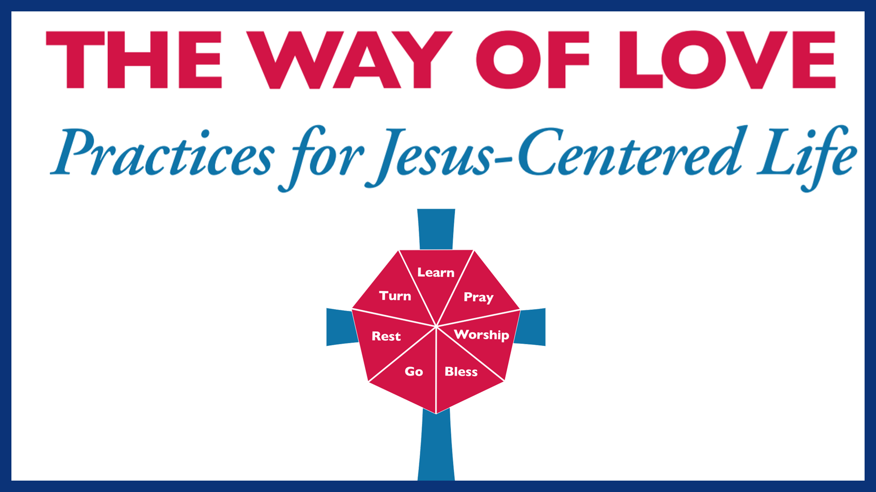
8:00pm – campfire with smores

Saturday

8:30am: Breakfast (pancakes and bacon)

9:30am – Morning Worship

10:15am: Session Two: (Learn)

11:00am: Snack

11:30am: Swimming/free time

12:30am – Lunch (grilled cheese etc)

1:30 to 3:30 – free time with some organized games/crafts etc.

4:00pm – Session Three: (Pray)

5:30pm – Dinner (spaghetti or tacos)

6:30pm – Session Four: (Bless) * we will do this session intergenerationally

8:30pm – campfire with smores
Sunday

8am – Breakfast (eggs, sausages and toast)

9am –Worship Service with Holy Communion & Session Five (Worship/Go)

11am – one more swim/start to pack up for home – lunch of leftovers

