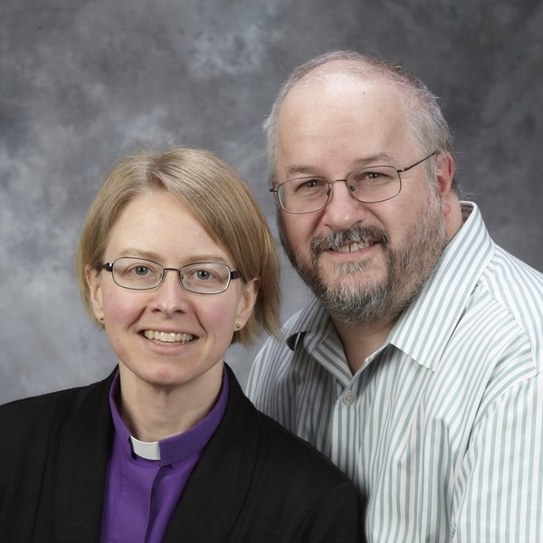
Our Mission Leaders

This year Nicholas Jesson, a Roman Catholic theologian, and his wife, Rev. Amanda Currie, a Minister of the Word and Sacraments in the Presbyterian Church in Canada, are co-leaders of the Mission. Each brings a wealth of experience and insight.
Nicholas Jesson has been an ecumenical leader in Saskatchewan for nearly 30 years and is currently serving as the Ecumenical Officer in Regina and formerly in Saskatoon. He is also a former executive director of the Prairie Centre for Ecumenism. A member of the Anglican-Roman Catholic Dialogue in Canada, he was previously part of a dialogue with the United Church. Among his other accomplishments, he edits a website, “Ecumenism in Canada” and is a member of the Commission on Faith and Witness of the Canadian Council of Churches.

Rev. Amanda Currie is a Minister of Word and Sacraments of the Presbyterian Church in Canada currently serving at the First Presbyterian Church in Regina. Rev. Currie served as Moderator of the Presbyterian Church in Canada from 2019-2021, providing leadership through the trying time of Covid. Her ecumenical experience is strong, including a term on the Board of the Prairie Centre for Ecumenism and representing that organization at the 11th Assembly of the World Council of Churches. She is currently on the Executive of the Canadian Council of Churches as one of the Vice Presidents.

Married for 22 years, our co-leaders have partnered in many ecumenical projects and ministry and participate actively in each other’s churches. We welcome their leadership at this year’s Mission!

THE 32nd ANNUAL
ECUMENICAL MISSION
OF STRATHCONA COUNTY

NO LONGER STRANGERS IN THE HOUSEHOLD OF GOD
October 22-25, 2023

Led by:
Nicholas Jesson
&
Rev. Amanda Currie

Sponsoring Churches
Ardrossan United 22 Main Street  780-922-2255 | 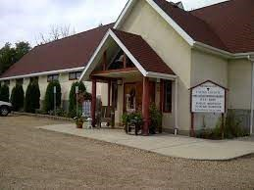
Bethel Lutheran  298 Bethel Drive  780-417-7775 | 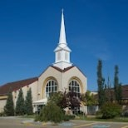
Glory Lutheran 22577 Highway 16  780-416-9594 | 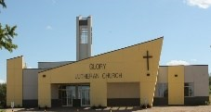
Mount Olivet Lutheran  205 Fir Street  780-467-5994 | 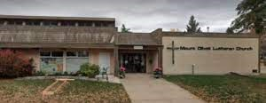
St. Thomas Anglican 4A Raven Drive 780-467-5730 | 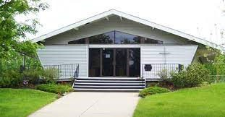
Salisbury United  2 Mission Street  780-467-7310 | 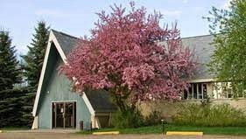
Sherwood Park United 20 Fir Street  780-467-7377 | 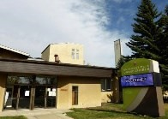
Our Lady of Perpetual Help  Roman Catholic  13 Brower Drive  780-467-5470 | 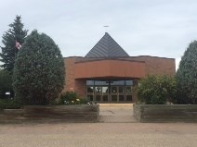

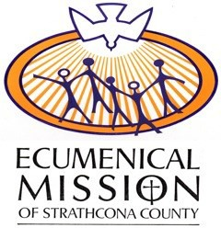
Mission Events
October 22-25, 2023

Sunday, October 22
7 pm Opening Evening
Worship Service
Sherwood Park United
That all may be one, ...
that the world may believe
(Jn. 17: 20-24)

Monday, October 23
2 pm Afternoon Tea
Bethel Lutheran
Christ is not divided
(1 Cor. 1: 20-27)
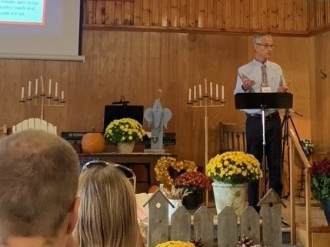

Monday, October 23
7 pm Evening Worship Service
Glory Lutheran
One body, many members
(1 Cor. 12: 12-31)

Tuesday, October 24 10 am Bible Study Ardrossan United
Christ breaks down dividing walls (Eph. 2: 11-22)
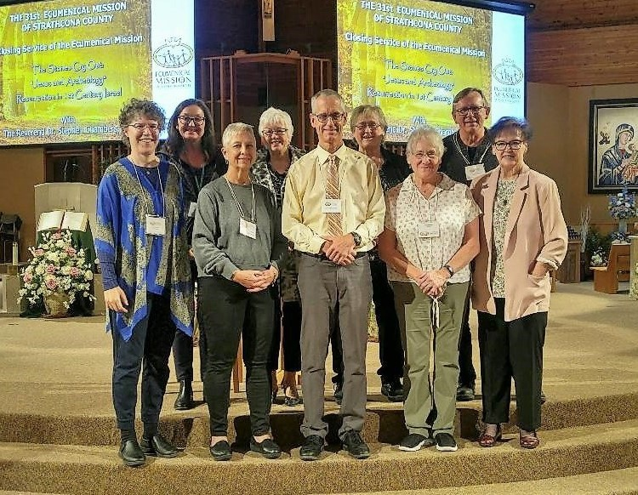

Tuesday, October 24
7 pm Evening Worship Service
St. Thomas Anglican Be reconciled (Matt. 5: 21-26)

Wednesday, October 25
2 pm Afternoon Tea
Mount Olivet Lutheran
Walking together with Christ (Lk. 24: 13-33a)

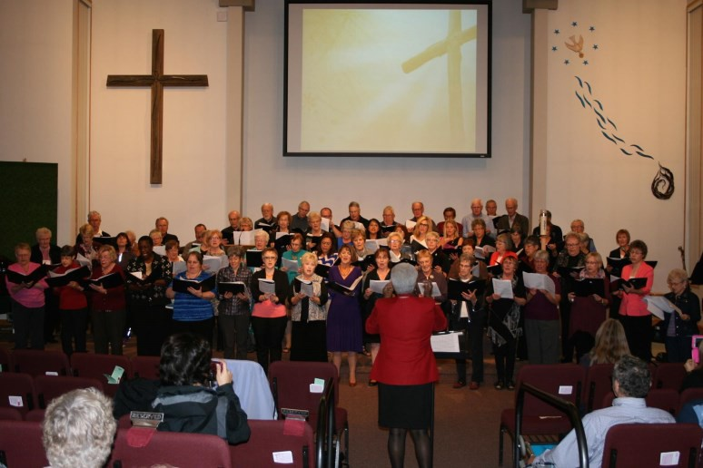

Wednesday, October 25
7 pm Closing Evening Worship
Service
Our Lady of Perpetual Help Roman Catholic
The gift of the Holy Spirit (Acts 2: 1-21)

Worship Together Learn Together Grow Together in Christ

