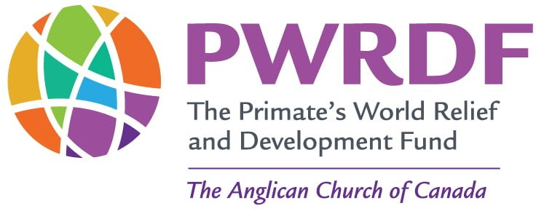

**Edmonton Diocese PWRDF Sunday**

**September 15, 2024- Draft**

1. Opening Sentence

*Proper 24 B:* I do not glory except in the cross of our Lord Jesus Christ, by which the world has been crucified to me, and I to the world

1. Hymn #1

*SFGP 2:* Make me a channel of your peace, or

*CP 418:* Draw the Circle Wide

1. Gathering of the community
2. Glory to God
3. Collect.

*Page 6 Alternative Collects. For second Sunday after Advent:* God of justice, clear our lives of hatred and despair and sow in us seeds of joy and peace, so that shoots of hope may spring forth in us as we await the coming of Christ, who with you and the Holy Spirit lives and reigns, One God now and forever, Amen.

1. First Reading

Proverbs 22. 1-2, 8-9

1. Psalm

Psalm 125

1. Second Reading

James 2. 1-5, 8-10, 14-17

1. Children’s Message

*This will 100 % down to the individual Church- but you could ask the children, and then the congregation- “Who is your neighbour?”*

1. Hymn #2

CP 73 One Bread, One Body, One Lord of All, *or*

SFGP 44 Part of the Family

1. Gospel

Luke 19: 29 – 37. The Parable of the Good Samaritan

1. Sermon

*See Below*

1. Apostles’ Creed
2. Prayers of the People
3. Confessions and absolutions
4. The Peace
5. Hymn #3

CP 576 For the Healing of the Nations

1. Prayers over the Gifts

*Evangelical Lutheran worship, 2006:* Holy God. Gracious and merciful,

You bring forth food from the earth and nourish your whole creation.

Turn our hearts towards those who hunger in any way, so that all may know your care;

And prepare us now to feast on the bread of life, Jesus Christ, Our Saviour and Lord. Amen

1. Eucharist
2. Lords Prayer
3. Breaking of the Bread
4. Communion
5. Prayer after communion

*Evangelical Lutheran Worship, 2006*: O God, we give you thanks that you have set before us this feast, the body and blood of your Son.

By your spirit strengthen us to serve all in need and to give ourselves away as bread for the hungry, through Jesus Christ our Lord. Amen.

1. Doxology
2. Blessing
3. Hymn #4

CP 585 Lord, Whose Love in Humbe Service

1. Dismissal

Sermon (4.5 minutes)

Let the words on my lips and the meditation of my heart be acceptable in Thy sight, O Lord, my Strength and my redeemer.

I’d like to start with a couple of notes from the confession and absolution we are familiar with:

“We have sinned against you….by what we have done and by what we have left undone.”

And, “We have not loved our neighbours as ourselves.”

Then we turn to the Samaritan assisting the robbed and beaten guy at the side of the road.

Jesus gives us that the Samaritan acts as the good neighbour we should all strive to be. He puts aside his differences and puts himself at personal risk to be that neighbour.

No one is claiming that being the good Samaritan is easy. Sometimes there are real personal challenges in this role:

·         Sometimes there are traditional reasons not to help - the Good Samaritan acted where others of his faith had turned their back and walked away.

·         Sometimes there are issues of capacity - the Good Samaritan knew that he couldn’t stay by the robbed guy for the few days it would take for him to recover so he paid an innkeeper to look after him.

·         Sometimes there are issues of personal risk - the Good Samaritan would have known what a dangerous road they were on. It was common for people to be robbed and beaten on that road, and the Samaritan knew that he, too, could be a victim.

·         In fact, Samaritans were often accused of being the robbers on that road, and he would have known that in some peoples’ minds, he would be seen as the perpetrator.

·         But still, he acted.

He acted, he stepped up and became that good neighbour.

It’s 2,000 years since that Parable, and the world needs good neighbours more than ever.

We live in a world where an estimated 345 million people face food insecurity.

A world of fires, droughts, hurricanes and tornadoes.

A world where Indigenous homes, schools and communities, here in Canada, have no access to clean drinking water;

Where nearly 1 in 3 children aged under 5 is malnourished;

A world where almost 2 billion people are lacking access to safe drinking water;

A world with approximately 100 million displaced people, where nationalism and racism are on the rise, borders are closing and people risk everything on boats to reach safe harbours.

And I put it to you today that, with figures like these, we all need to be good neighbours.

And, luckily, because we have the PWRDF we can be good neighbours.

We can be good neighbours to victims of fires and floods here in Canada;

To those working in hospitals in Gaza risking bombs;

To farmers in Kenya, Zimbabwe, Malawi and Mozambique - feeding families at the forefront of climate change;

To Indigenous groups in Canada with health and water priorities;

To those without access to pandemic support in India and Mali;

To those living through the war in Ukraine;

To refugees in South Sudan, Tanzania, Sri Lanka and Ethiopia;

To those being discriminated against in El Salvador;

To those surviving floods in Pakistan, hurricanes in Cuba and earthquakes in Haiti.

And to countless other people around the world, who just need a good neighbour.

The PWRDF is the Samaritan to all these people.

By supporting the PWRDF, we can ensure that “loving our neighbours as ourselves” is something we “did not leave undone” today.

Thank you.