**Join us in the Death Cafe YEG!**

**Friday, December 20, 2024** (*Monthly Meeting*)

**6110 Fulton Road 7:00 pm**

St. Augustine’s Anglican Church – Lower Level, Livingroom (Elevator Available)

This **non-religious group** is for those interested in exploring the topics of death, dying, and end-of-life care in a safe and supportive environment. Inspired by the IDEA Cafe, Cafe Lovers, Conscious Dying, and Socrates Cafe philosophies, we gather to have open and honest conversations about mortality, meaning, and what it means to live fully. Whether you are curious, fearful, or simply interested in sparking meaningful discussions, we invite you to join us for thought-provoking conversations and connections with like-minded individuals. Let's embrace the taboo and explore the inevitable together.

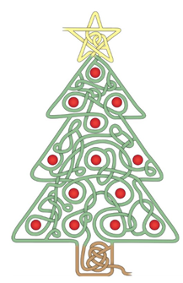

Previous topics discussed with age group ranging from 30-75 years young, within the individual’s personal experience:

- how the narrative of our loved ones forever remains in our story

- how we are all spiritual on a human journey, not humans on a spiritual journey

- out of body experience - supernatural signs

- rituals in healing - processing grief

- death and dying - journeying through suicide

- palliative care - medical assistance in dying

- thick listening in thin places - norms within cultures

*Question? Text: Helen @ 780-233-9322 for Zoom link available*

*Facilitator for this non-structured conversation group is Helen, who is a Spiritual Director and works as a Chaplain/ Spiritual Health Provider at the University of Alberta Hospitals and the Canadian Armed Forces.*