Fall $5 Medical Card Fundraiser
Four Sundays to Make a Difference!

Throughout the month of September, we encourage every parish to take up a coffee-hour collection for medical cards for our brothers and sisters in Burundi, Africa.
“People in our diocese have done an amazing job raising funds and making a difference in the lives of many since we began this campaign in 2018,” with heartfelt thanks, the Rev. Rebecca Harris and the Rev. Danielle Key.

i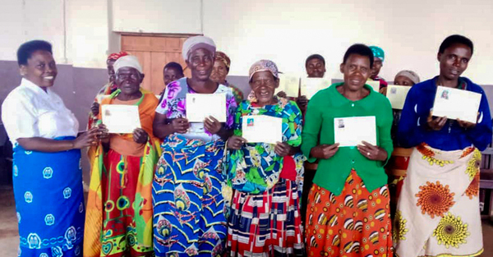

A $5 medical card covers 80% of the cost of medical bills for each cardholder for a full year. Sadly, this coverage is out of reach for most of the people living in Buye diocese. 100% of donations go directly to this worthwhile cause. There are no administrative fees.

Please send all donations directly to John Gee at the Synod Office or donate online at Edmonton.anglican.ca/donate – select “Buye Medical Cards” from dropdown menu

